Database Engine

🧠 What Is a Database Engine?
# Source: AI Source: Provided by: [Data Path: Persons Table -> ID Column: 1, Name_En Column: Motasem Essam] -> From: [ChatGPT] on [6/10/2026]
The Database Engine is the core component of a Database Management System (DBMS) responsible for the actual storage, retrieval, and manipulation of data.
Think of it as the "heart" or "brain" of the database — it executes queries, manages data files, handles transactions, and enforces rules like constraints and indexes.

🔍 Key Responsibilities of a Database Engine
# Source: AI Source: Provided by: [Data Path: Persons Table -> ID Column: 1, Name_En Column: Motasem Essam] -> From: [ChatGPT] on [6/10/2026]
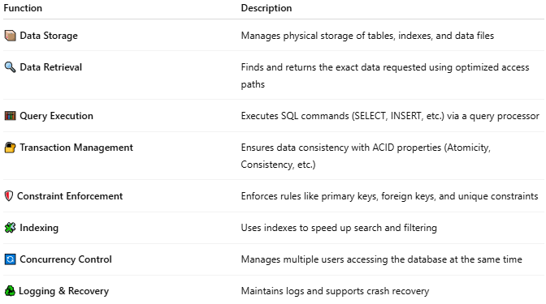
Function | Description
📦 Data Storage | Manages physical storage of tables, indexes, and data files
🔍 Data Retrieval | Finds and returns the exact data requested using optimized access paths
🧮 Query Execution | Executes SQL commands (SELECT, INSERT, etc.) via a query processor
🔐 Transaction Management | Ensures data consistency with ACID properties (Atomicity, Consistency, etc.)
🛡️ Constraint Enforcement | Enforces rules like primary keys, foreign keys, and unique constraints
🧩 Indexing | Uses indexes to speed up search and filtering
🔄 Concurrency Control | Manages multiple users accessing the database at the same time
♻️ Logging & Recovery | Maintains logs and supports crash recovery

🔧 Examples of Database Engines
# Source: AI Source: Provided by: [Data Path: Persons Table -> ID Column: 1, Name_En Column: Motasem Essam] -> From: [ChatGPT] on [6/10/2026]
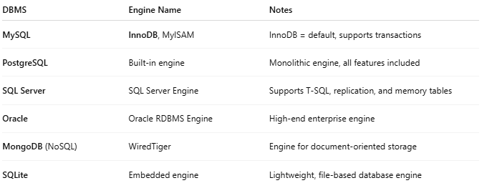
DBMS | Engine Name | Notes
MySQL | InnoDB, MyISAM | InnoDB = default, supports transactions
PostgreSQL | Built-in engine | Monolithic engine, all features included
SQL Server | SQL Server Engine | Supports T-SQL, replication, and memory tables
Oracle | Oracle RDBMS Engine | High-end enterprise engine
MongoDB (NoSQL) | WiredTiger | Engine for document-oriented storage
SQLite | Embedded engine | Lightweight, file-based database engine

🔁 Analogy
# Source: AI Source: Provided by: [Data Path: Persons Table -> ID Column: 1, Name_En Column: Motasem Essam] -> From: [ChatGPT] on [6/10/2026]
🧱 Database Engine is like the engine of a car —
It powers everything, but you still need a dashboard (DBMS tools) to operate it easily.

💡 Bonus: Pluggable Engines
# Source: AI Source: Provided by: [Data Path: Persons Table -> ID Column: 1, Name_En Column: Motasem Essam] -> From: [ChatGPT] on [6/10/2026]
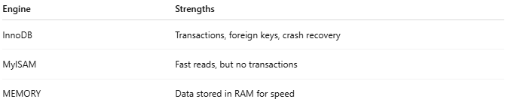
In some DBMSs (like MySQL), you can switch between engines depending on your needs:
Engine | Strengths
InnoDB | Transactions, foreign keys, crash recovery
MyISAM | Fast reads, but no transactions
MEMORY | Data stored in RAM for speed

📌 Summary
# Source: AI Source: Provided by: [Data Path: Persons Table -> ID Column: 1, Name_En Column: Motasem Essam] -> From: [ChatGPT] on [6/10/2026]
The Database Engine is the central software layer that physically stores, processes, and returns data in a DBMS. Without it, the database system can’t function.

